**Neural Network take-home assignment 2:**

**Prepared by Haihan**

In this exercise we are going to focus on understanding the use of packages such as Tensforflow and Keras for neural network building tasks. *Feel free to push your results to your public git repos.* The soft deadline is Monday Jan. 22, 2018.

**Task 0:**

Please install Tensorflow on your machine for your version of Python 3.x. Then please install Keras.

**Task 1:**

Your first task is to navigate to <https://www.tensorflow.org/get_started/get_started> and read the article. Then implement the example in <https://www.tensorflow.org/get_started/mnist/beginners>.

**Task 2:**

Complete <https://www.tensorflow.org/get_started/mnist/pros>

**Task 3:**

Using Keras (sequential model), implement a 2 Hidden layer Multilayer Perceptron classifier with a dropout layer before the final softmax output layer. It will look something like this:

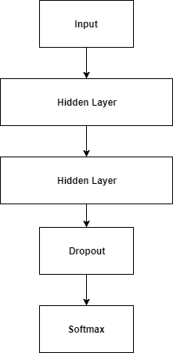

Initially, the number of neurons *n* in the hidden layers (which are [**Dense layers**](https://keras.io/layers/core/)) is 10, with sigmoid activation functions. The dropout out ratio is 0.25. The final output layer is also a Dense layer with *n* = 1 and softmax activation.

Your neural net will be trained on the <https://archive.ics.uci.edu/ml/datasets/banknote+authentication#> dataset. You can use Adadelta as your initial optimizer and binary cross-entropy loss (in general for classes greater than 2 it’s categorical cross-entropy that needs to be used). For holdout, use an 85-15 train/test split. Usually 10 epochs (training runs of the entire dataset) is a good place to start. You will need to implement a one-hot encoding to convert the integer classes to one hot encoded classes, have a look at <http://scikit-learn.org/stable/modules/generated/sklearn.preprocessing.OneHotEncoder.html>. Remember you can do both training and validation in one call of model.fit().

Experiment with using different hidden layer neuron numbers, dropout ratios, and optimizers and see what maximum accuracy you can obtain. Summarize your results in a spreadsheet and/or report.